Nate Bartlett Node 04
Server running + index.html (this is before any major additions)
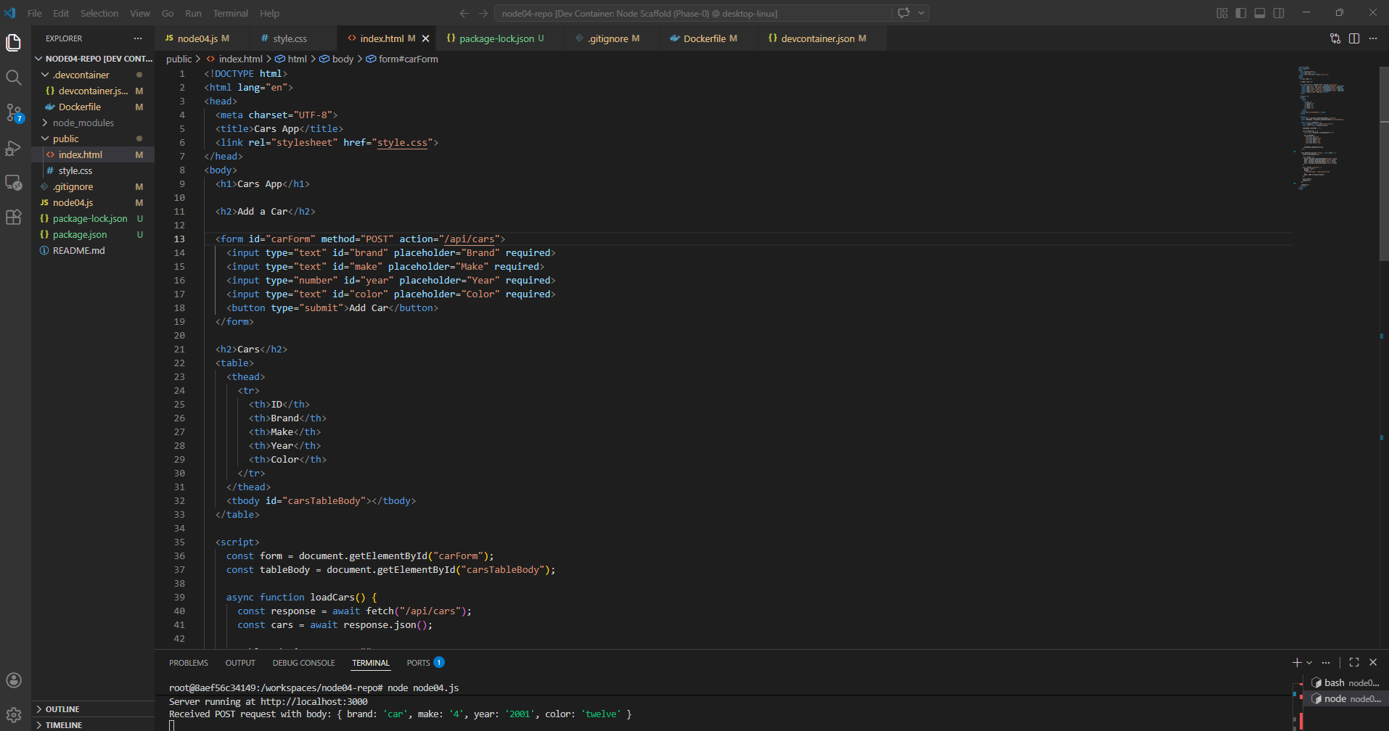
Get request: (bruno isn’t displaying the table for some reason)
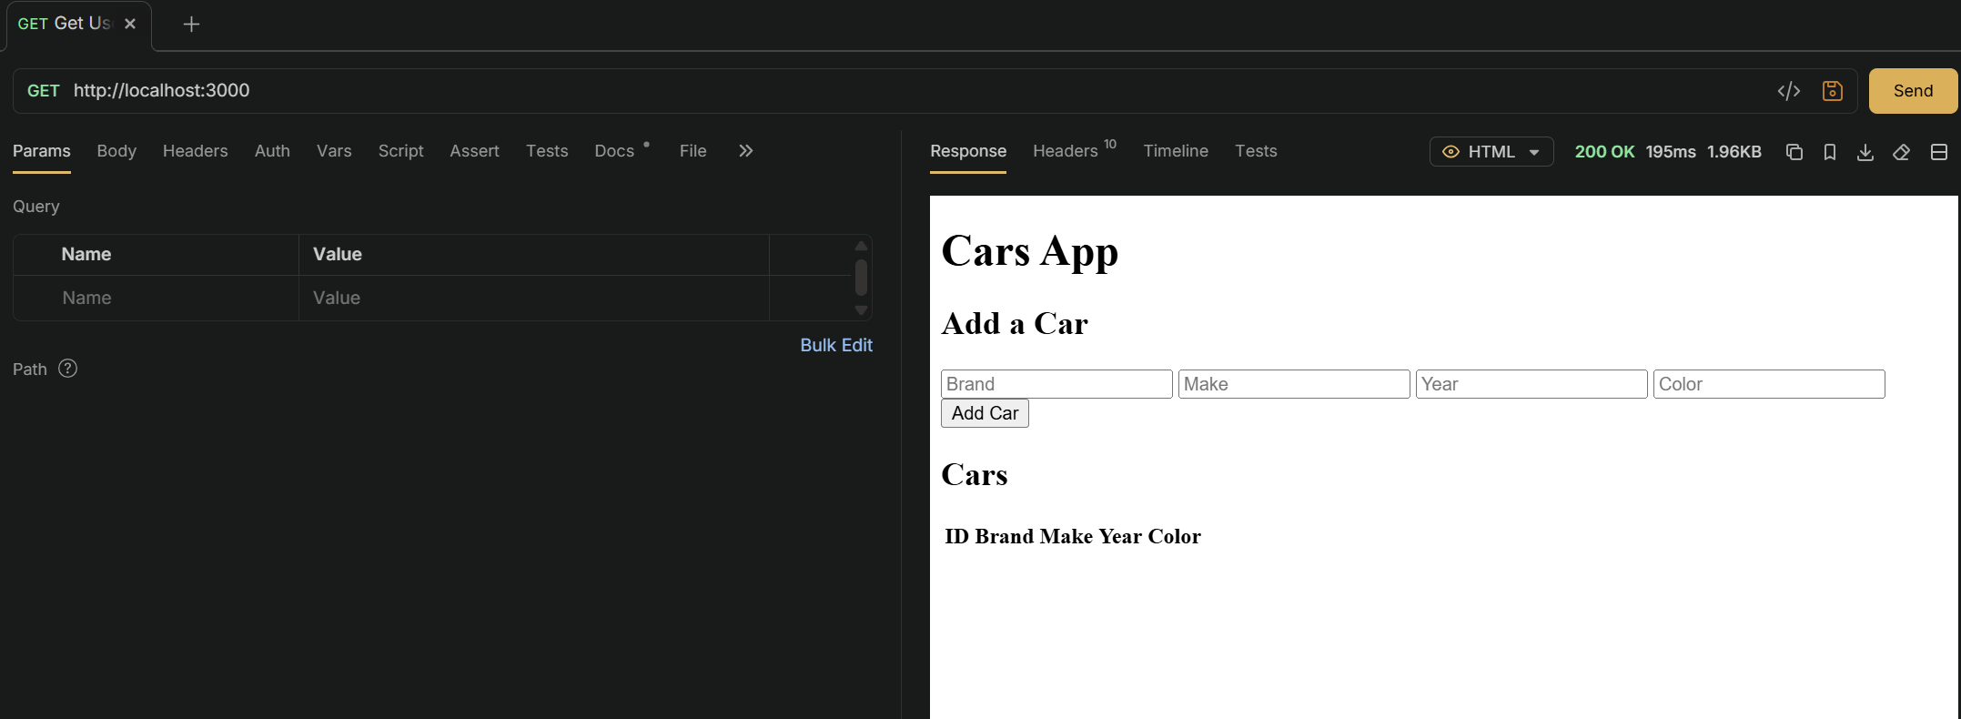
Get request (api):
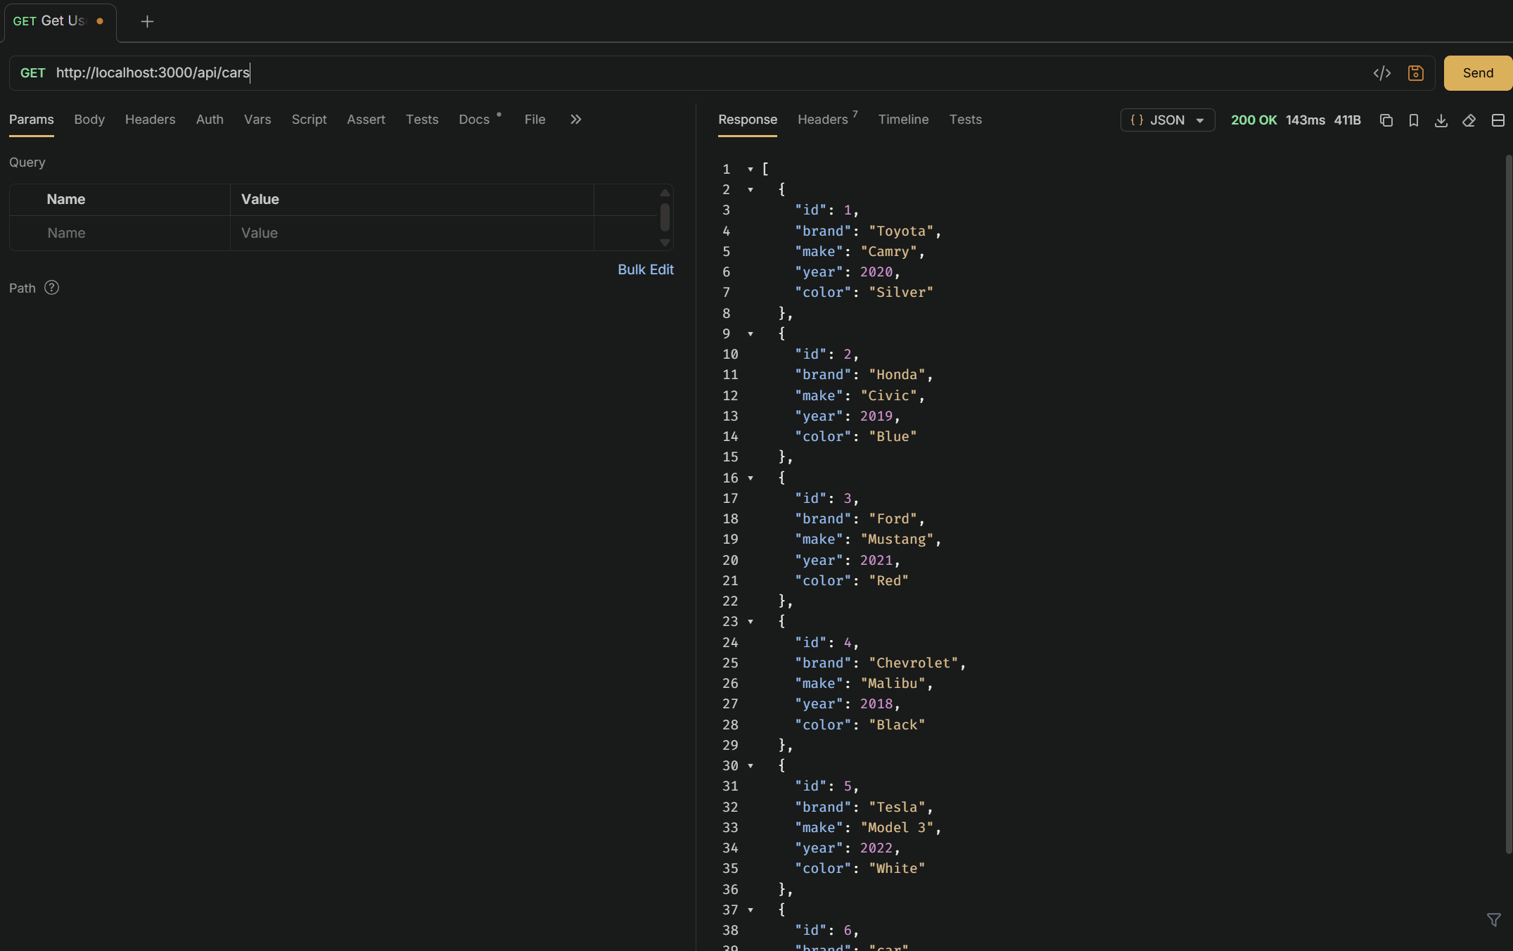
Post Request: (creating a new car)
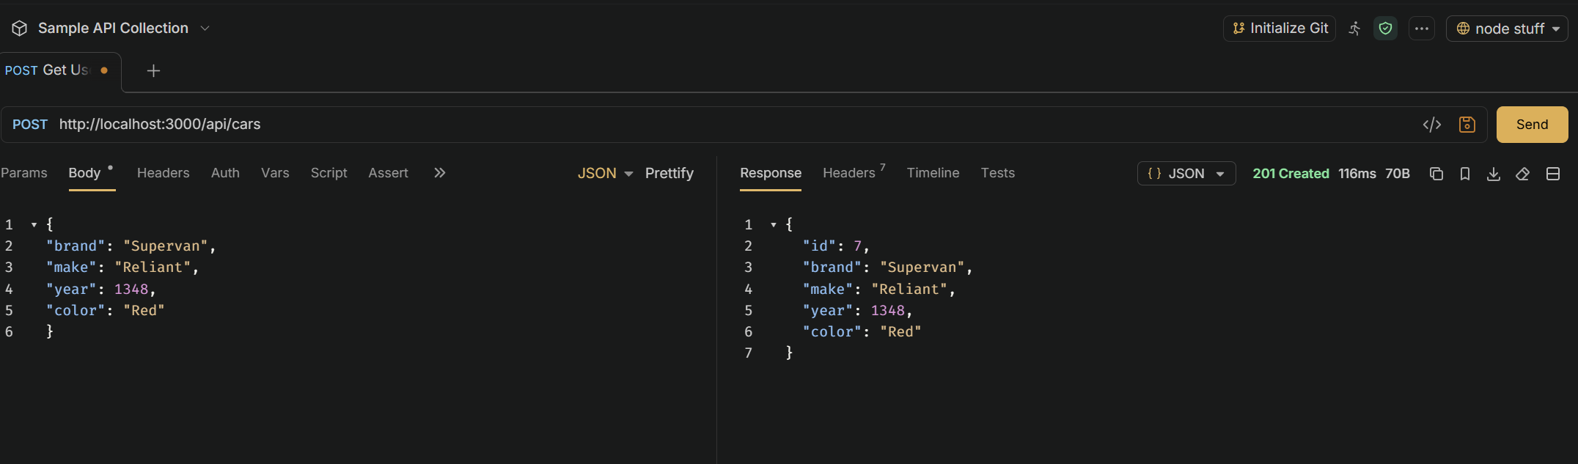
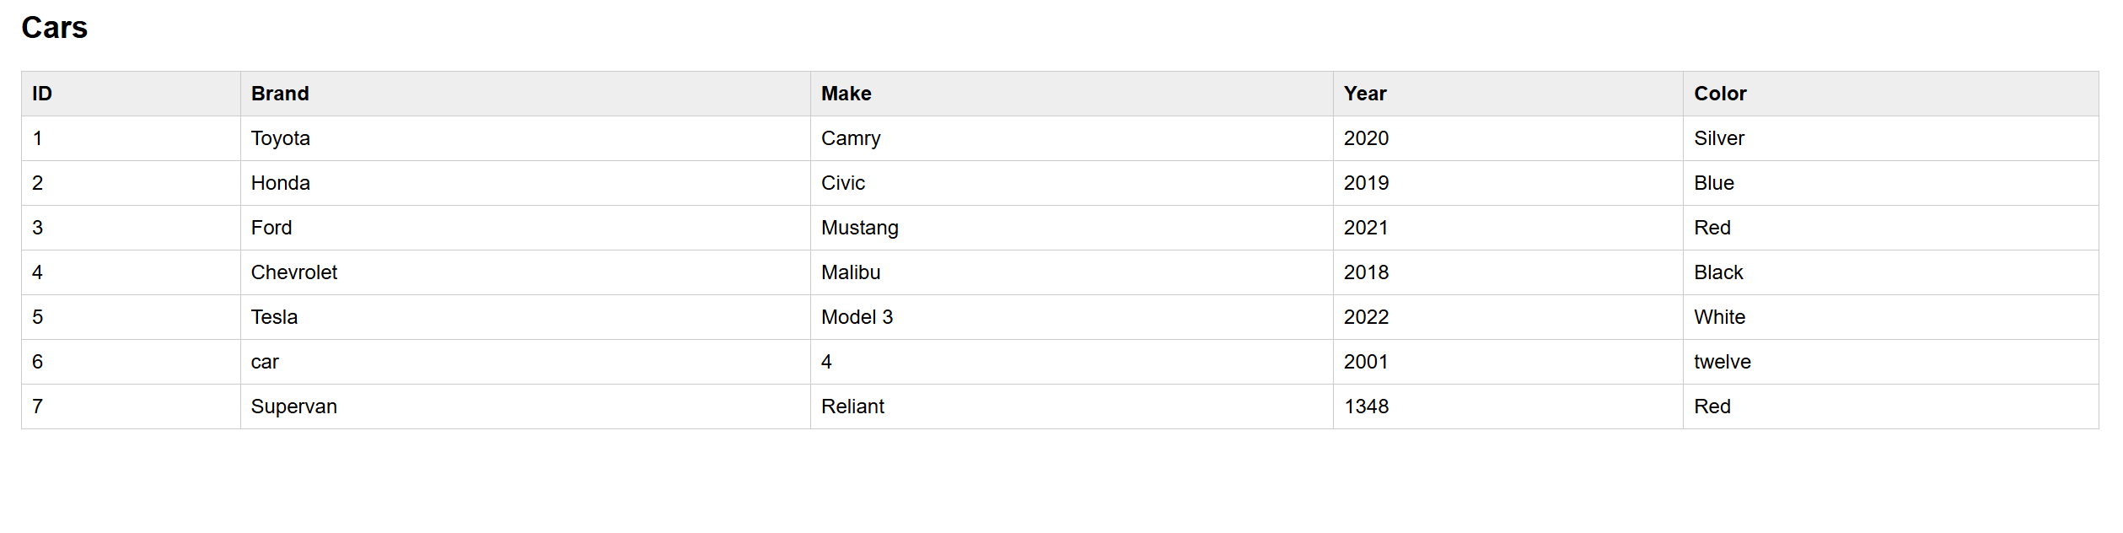
Put Request: (changing something about the car)
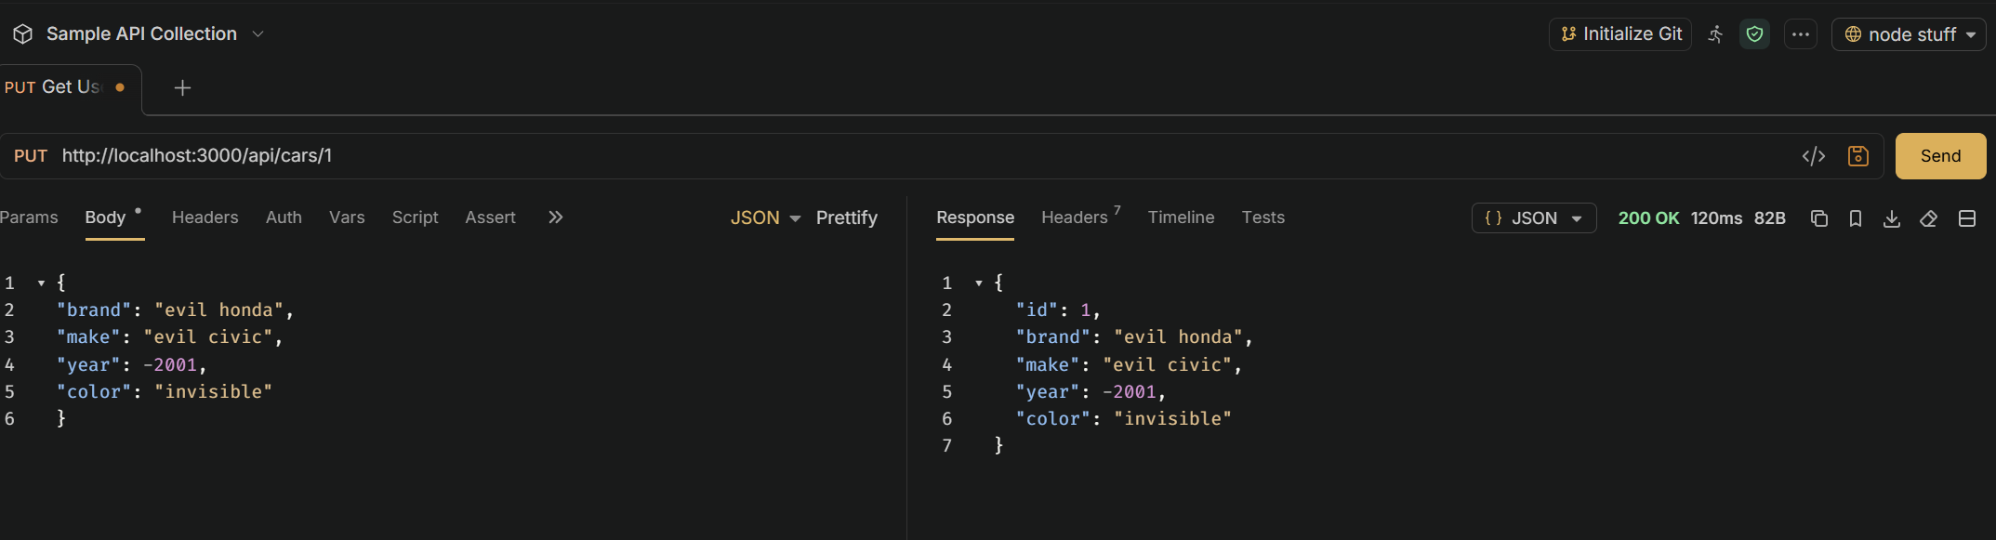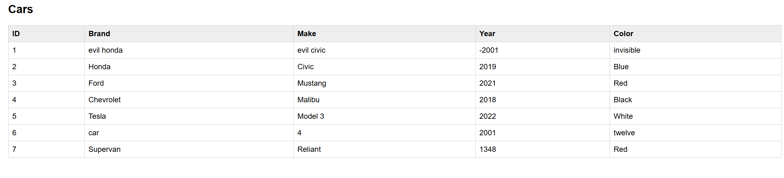
Delete:
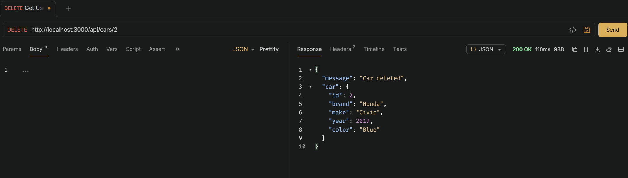
Update/Delete Button:
Before: (I added a new column to the table for the two buttons. Each has it’s own new function. Delete just sends a delete request for the car with the selected ID, and update sends an alert asking for new info for each of that car’s columns in the table.)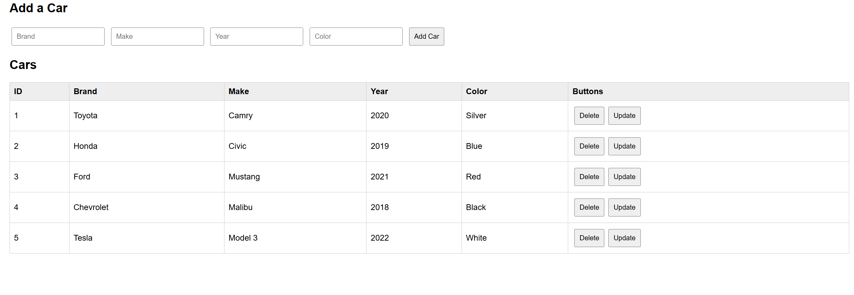
After:
(Car 1 has been deleted, and car 4 has been updated to be evil.)
